**Research paper- Regional Hindi Phonetics**

**A PROJECT REPORT**

***Submitted by***

**Stuti Yadav**(21BCE10543)

**Pritha Dey**(21BCE10707)

**Sajal Saxena**(21BCE10515)

**Shashwat Pandey**(21BCE11596)

**Priyanshu Dubey**(21BCE11560)

*in partial fulfillment for the award of the degree*

*of*

**BACHELOR OF TECHNOLOGY**

*in*

**COMPUTER SCIENCE AND ENGINEERING**



**SCHOOL OF COMPUTING SCIENCE AND ENGINEERING**

**VIT BHOPAL UNIVERSITY**

**KOTHRI KALAN, SEHORE**

**MADHYA PRADESH - 466114**

August 2022

**VIT BHOPAL UNIVERSITY,KOTHRI KALAN, SEHORE**

**MADHYA PRADESH – 466114**

**BONAFIDE CERTIFICATE**

Certified that this project report titled “**Research paper- Regional Hindi Phonetics**” is the bonafide work of “**Stuti Yadav(21BCE10543), Pritha Dey (21BCE10707), Sajal Saxena (21BCE10515),Shashwat Pandey (21BCE11596), Priyanshu Dubey(21BCE11560)**” who carried out the project work under my supervision. Certified further that to the best of my knowledge the work reported here does not form part of any other project / research work on the basis of which a degree or award was conferred on an earlier occasion on this or any other candidate.

**PROGRAM CHAIR PROJECT GUIDE**

**Dr. Sandip Mal Dr. Nirmala E.**

School of Computer Science and Engineering School of Computer Science and Engineering

VIT BHOPAL UNIVERSITY VIT BHOPAL UNIVERSITY

The Project Exhibition I Examination is held on 30/09/2022

**ACKNOWLEDGEMENT**

First and foremost I would like to thank the Lord Almighty for His presence and immense blessings throughout the project work.

I wish to express my heartfelt gratitude to Dr. Sandip Mal, Head of the Department, School of

Computer Science and Engineering for much of his valuable support and encouragement in carrying out this work.

I would like to thank my internal guide Mrs. Dr. Nirmala E., for continually guiding and actively

participating in my project, giving valuable suggestions to complete the project work.

I would like to thank all the technical and teaching staff of the School of Aeronautical Science, who extended directly or indirectly all support.

Last, but not the least, I am deeply indebted to my parents who have been the greatest support while I worked day and night for the project to make it a success.

**LIST OF ABBREVIATIONS**

1.IPA-International Phonetic Alphabet-an alphabet developed in the 19th century to accurately represent the pronunciation of languages.

2.NLP- Natural Language Processing

**LIST OF FIGURES**

| **FIGURE NO.** | **TITLE** | **PAGE NO.** |
| --- | --- | --- |
| 1. | IPA vowel chart | 14 |
| 2. | Complete sentence PRAAT representation | 14 |
| 3. | F1 representation **काली** | 15 |
| 4. | F2 representation **काली** | 15 |
| 5. | F1 representation **कली** | 16 |
| 6. | F2 representation **कली** | 16 |
| 7. | Complete sentence PRAAT representation | 16 |
| 8. | F1 representation **बात** | 17 |
| 9. | F2 representation **बात** | 17-18 |
| 10. | F1 representation **बीत** | 18 |
| 11. | F2 representation **बीत** | 18 |
| 12. | Complete sentence PRAAT representation | 18 |
| 13. | F1 representation **काश** | 19 |
| 14. | F2 representation **काश** | 20 |
| 15. | F1 representation **केश** | 20 |
| 16. | F2 representation **केश** | 21 |
| 17. | Complete sentence PRAAT representation | 21 |
| 18. | F1 representation **तेल** | 22 |
| 19. | F2 representation **तेल** | 22 |
| 20. | F1 representation **तोल** | 23 |
| 21. | F2 representation **तोल** | 23 |
| 22. | Complete sentence PRAAT representation | 23 |
| 23. | F1 representation **तिल** | 24 |
| 24. | F2 representation **तिल** | 25 |
| 25. | F1 representation **ताल** | 25 |
| 26. | F2 representation **ताल** | 26 |
| 27. | F1 and F2 formant IPA frequency | 27 |

**LIST OF TABLES**

| **TABLE NO.** | **TITLE** | **PAGE NO.** |
| --- | --- | --- |
| 1. | Compiled Observed Statistics  F1 and F2 mean with standard deviation | 28 |

**ABSTRACT**

| **CHAPTER NO.** | **TITLE** | **PAGE NO.** |
| --- | --- | --- |
|  | List of abbreviations  List of figures  List of tables | iii.  iv.  v. |
| 1. | **Introduction**  1.1 Introduction  1.2 Organization of thesis  1.3 NLP  1.4 Motivation for the work  1.5 Software implemented- PRAAT  1.6 Problem Statement  1.7 Objective of the work  1.8 Summary | 1  1  1  2  2  3  3  5 |
| 2. | **Experimental Data**  2.1 Observed analysis | 6 |
| 3. | **Results and Discussion** | 27 |
| 4. | **Conclusion** | 28 |
| 5. | **References** | 29 |

**Introduction**

This article describes the observation through the experiment conducted to compare the results derived from accumulated data(different tokens) and reference journal, in Hindi language, to prove that pronunciation of various vowels has changed accordingly,

and that the originally published journal is no more accurate and the new variations need to be added in the NLP system.

NLP i.e. Natural Language Processing is a branch of Artificial Intelligence under Computer Science, concerned with giving computers the ability to understand text and spoken words in much the same way human beings can.

Human language is filled with ambiguities that make it incredibly difficult to write software that accurately determines the intended meaning of text or voice data. Homonyms, homophones, sarcasm, idioms, metaphors, grammar and usage exceptions, variations in sentence structure—these just a few of the irregularities of human language that take humans years to learn, but that programmers must teach natural language-driven applications to recognize and understand accurately from the start, if those applications are going to be useful.

Hence, NLP combines computational linguistics—rule-based modeling of human language—with statistical, machine learning, and deep learning models. Together, these technologies enable computers to process human language in the form of text or voice data and to ‘understand’ its full meaning, complete with the speaker or writer’s intent and sentiment.

Several NLP tasks break down human text and voice data in ways that help the computer make sense of what it's ingesting. Some of these tasks include the following:

– Speech recognition

– Part of speech tagging

– Word sense disambiguation

– Coreference resolution

– Sentiment Analysis

– Natural language generation.

**Motivation for the work**

As we travel to different parts of India, we get to see that the accent of people, while speaking a specific language (here, Hindi) changes, as it is influenced by their mother tongue, especially if they are multilingual. The difference in linguistics is something that says a lot about the diversity of the way the word is spoken.Although the same word it could be, different background of life makes a slight difference in their accents.

This causes inaccuracy of results in speech to text or similar applications like Alexa or Google Assistant.

Hence, our motive is to find standard variants and deviations of that language, specifically the vowels, and later adding it to the NLP system for more accuracy in speech related NLP tasks.

This will lead AI to recognize the words spoken more easily irrespective of the accent to a great extent of accuracy.

**Software Implemented: PRAAT**

PRAAT is a [free](https://en.wikipedia.org/wiki/Free_software) [computer software](https://en.wikipedia.org/wiki/Computer_software) package for [speech analysis](https://en.wikipedia.org/wiki/Speech_analysis), synthesis and manipulation in [phonetics](https://en.wikipedia.org/wiki/Phonetics).[[4]](https://en.wikipedia.org/wiki/Praat#cite_note-4) It was designed, and continues to be developed, by [Paul Boersma](https://en.wikipedia.org/wiki/Paul_Boersma) and [David Weenink](https://en.wikipedia.org/w/index.php?title=David_Weenink&action=edit&redlink=1) of the [University of Amsterdam](https://en.wikipedia.org/wiki/University_of_Amsterdam). It can run on a wide range of [operating systems](https://en.wikipedia.org/wiki/Operating_system), including various versions of [Unix](https://en.wikipedia.org/wiki/Unix), [Linux](https://en.wikipedia.org/wiki/Linux), [Mac](https://en.wikipedia.org/wiki/Mac_OS) and [Microsoft Windows](https://en.wikipedia.org/wiki/Microsoft_Windows) (2000, XP, Vista, 7, 8, 10). The program supports [speech synthesis](https://en.wikipedia.org/wiki/Speech_synthesis), including [articulatory synthesis](https://en.wikipedia.org/wiki/Articulatory_synthesis).

*– What is Praat used for?*

Praat can read sounds recorded with the program or audio files(mp3 and wav types are commonly recommended) recorded in another way. Once the application is launched, it will generate a graph of waves that indicate intonation, intensity, [volume](https://en.softonic.com/downloads/volume-for-windows), and other complex details. Proving its handy purpose for deeply learning linguistics, it is able to isolate certain sounds or filter frequencies either manually or using scripts.

You will have access to spectrograms—a visual representation of the sound changes over time. It permits you to produce speech from a pitch curve and filters or from various muscle activities. Furthermore, it grants you the ability to alter existing speech utterances wherein you can customize the pitch, intensity, and duration of the speech.

Here, you have the capacity to custom-label your sample using the IPA. Not only that, you can even annotate your sound segments based on the specific variable you are aiming to examine. It also supports [multi-language](https://en.softonic.com/downloads/multi-language) text-to-speech features that empower you to section the sound into words and phonemes. It's difficult to get to grips with, though. An extensive manual is available but it's aimed mainly at linguistic experts.

**Problem Statement**

Problem: Insufficient data in NLP regarding variations in values of terms related to phonetics in accents of a language.

Background: As we come from multicultural backgrounds, it is noticed that the pattern of spelling certain words are different for different people. However, the AI is sometimes unable to recognize the words due to this existing difference.

Relevance: Considering a situation, if we spell “kali” /kʌli/ to Google assistant, it considers it as “kaali” /ka:li/. This creates inaccuracy of results especially while using speech recognition systems, like Google Assistant used above.

Objective: This research aims to prove that necessary variations are required in the values of phonetic terms, that NLP has, to increase the accuracy of any AI thus making Human and machine co-ordination and communication much better.

**Experimental Data**

For this research we have collected data of 8 students from different regions of India present in the campus itself and performed Vowel Formant Analysis on their voices on the specified sentences in Hindi and analyzed how their voices are different from the originally specified vocal formant frequency.

We referred to Ladefoged(2006) for the theory and positional analysis of vowels as shown in the chart given below which depicts IPA vowel characteristics.

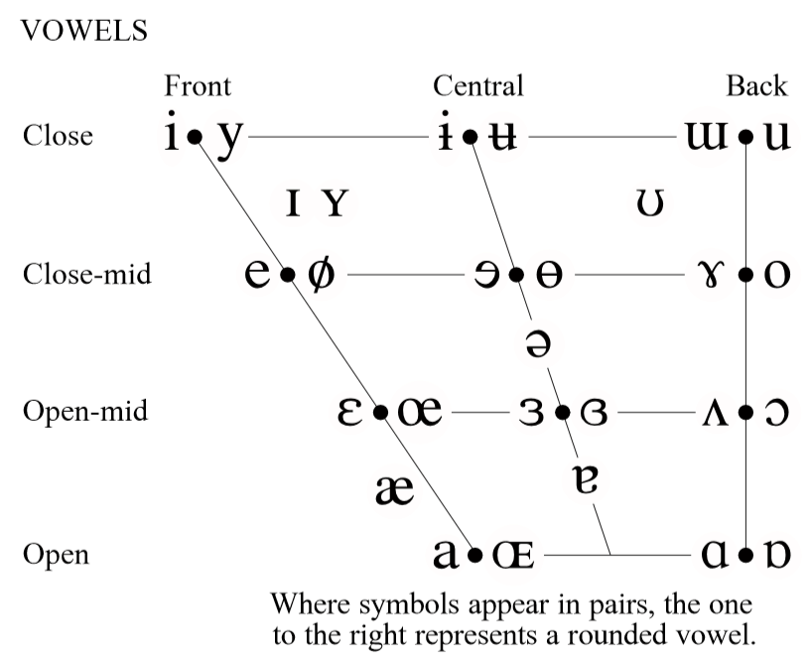

Fig.1

In the sentences used for analysis we have included the vowels from all 3 front, central and back vowels placement.

The following 5 sentence are as follows:

1.**काश** **केश** होते।

2.**बात बीत** गई।

3.**काली कली** कोमल है।

4.**तेल तोल** लेना।

5.**तिल ताल** के पास है।

So the derived vowels that we considered for the evaluation are in the CVC form that is Consonant Vowel Consonant form. That are अ (ʌ), आ(a:), इ(I), ई(i:), ए(e), ओ (o).

After recording the 40 samples we analyzed each of the samples on PRAAT software and found the F1 And F2 formants.

The first two formants are important in determining the quality of vowels, and are frequently said to correspond to the open/close (or low/high) and front/back dimensions (which have traditionally been associated with the shape and position of the [tongue](https://en.wikipedia.org/wiki/Tongue)). Thus the first formant *F*1 has a higher frequency for an open or low vowel such as [a] and a lower frequency for a closed or high vowel such as [i] or [u]; and the second formant *F*2 has a higher frequency for a front vowel such as [i] and a lower frequency for a back vowel such as [u].

Considering the example:

**काली कली** कोमल है

Here we are checking the Formants of the vowels /a:/ and /ʌ/ that are present in the words काली /ka:li/ and कली /kʌli/ respectively.

Initially, the sentence is recorded and uploaded on PRAAT software in .mp3 or .wav format.

Then, every word of the sentence is separated by boundaries created using a text grid.

Below is the image representing the process.

Red dots represent the formants.

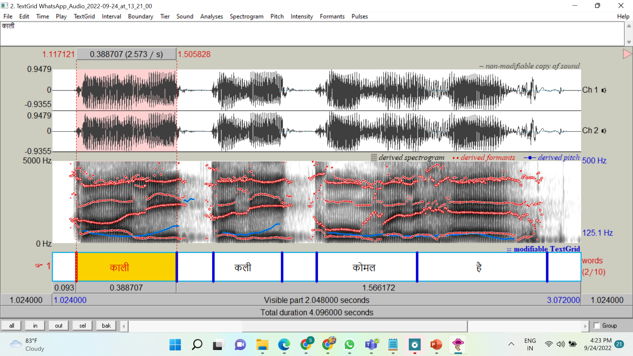

Fig.2

Now, we select the first word, काली and then check the formants of the segment that spells /a:/.

Once the segment is selected, we look for the lowermost dark patch in the segment. This lowermost dark patch represents **F1**.

To check the F1 of vowel we select the point that is stable across the larger part in the selected area.

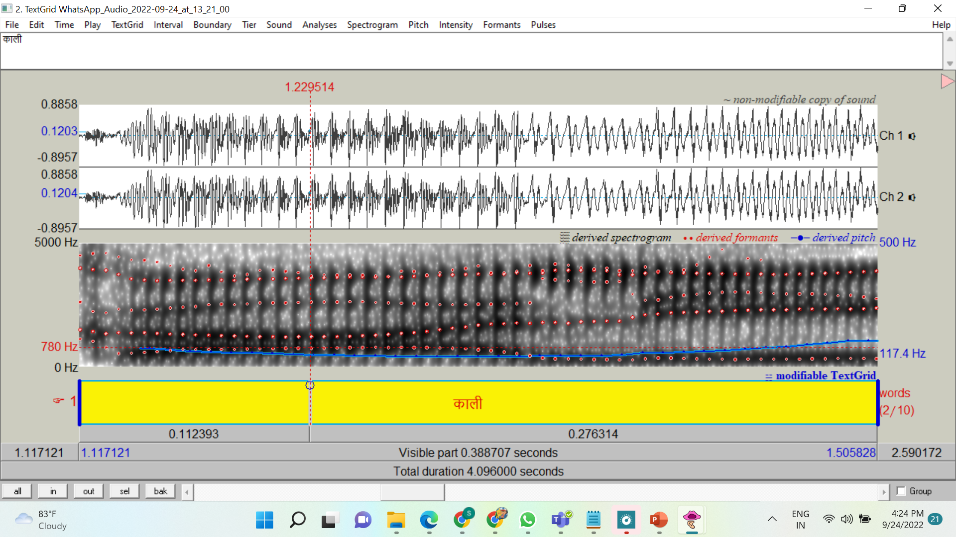

Fig.3

F1: 780 Hz

The second-most dark patch is that of **F2**. The value of F2 is taken by considering the highest value among all the formant dots. But we need to make sure that the renge is taken in the mid region such that consonants do not affect the sound. While for diphthongs, we consider the starting section of formant.

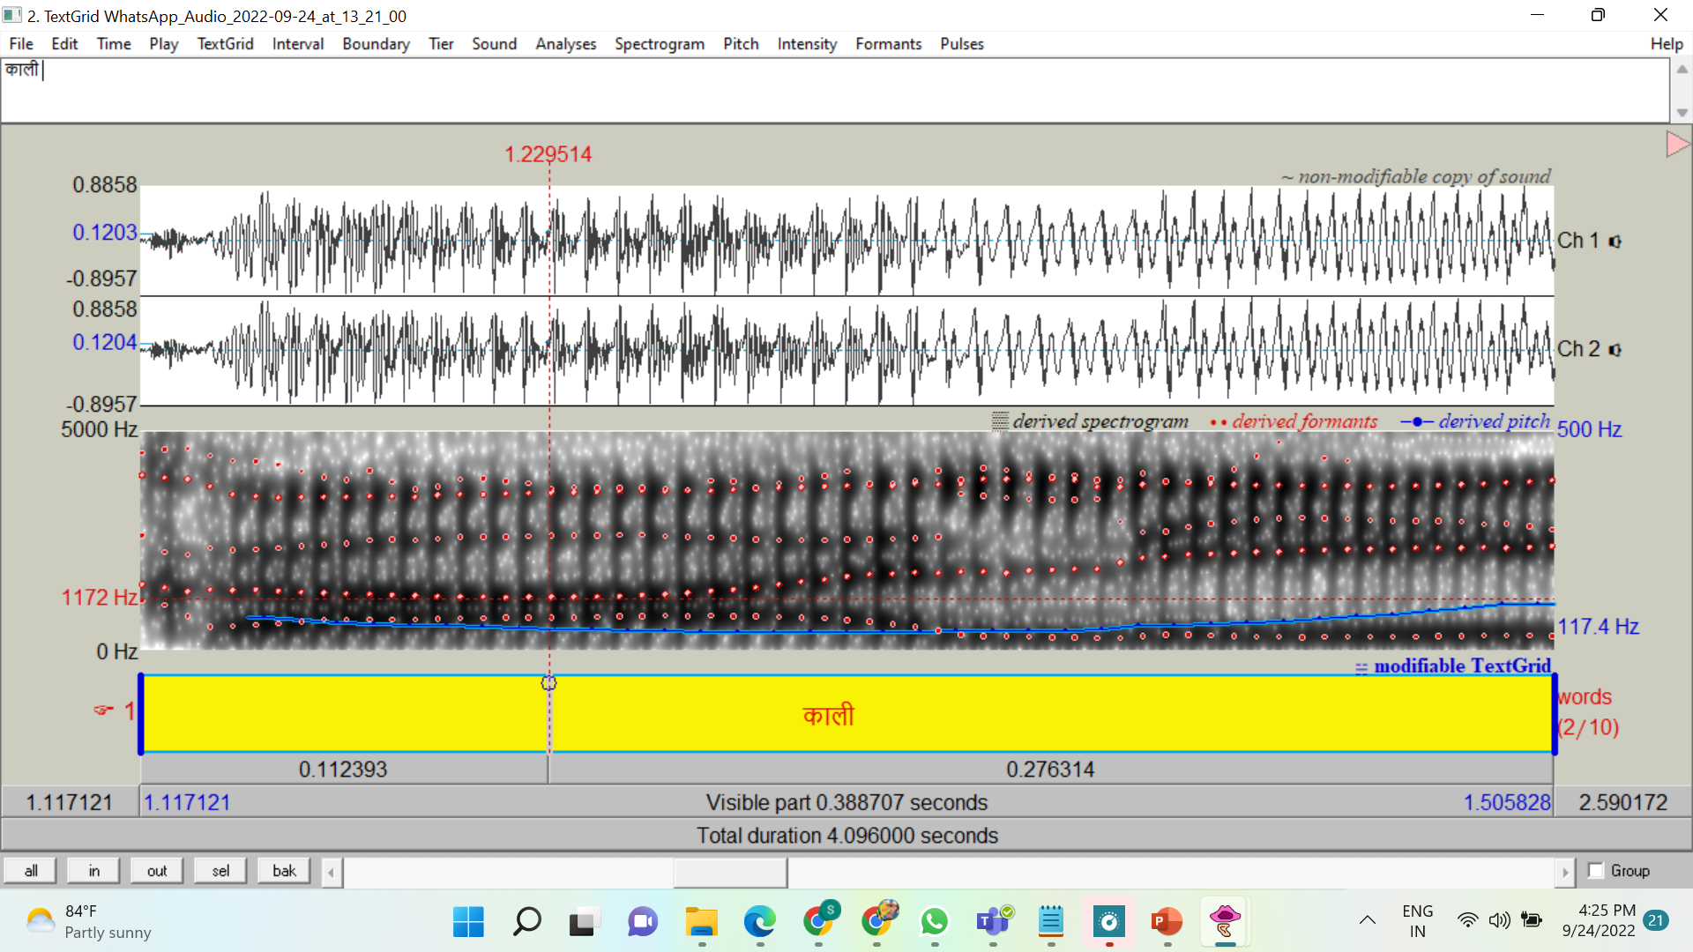

Fig.4

F2: 1172 Hz

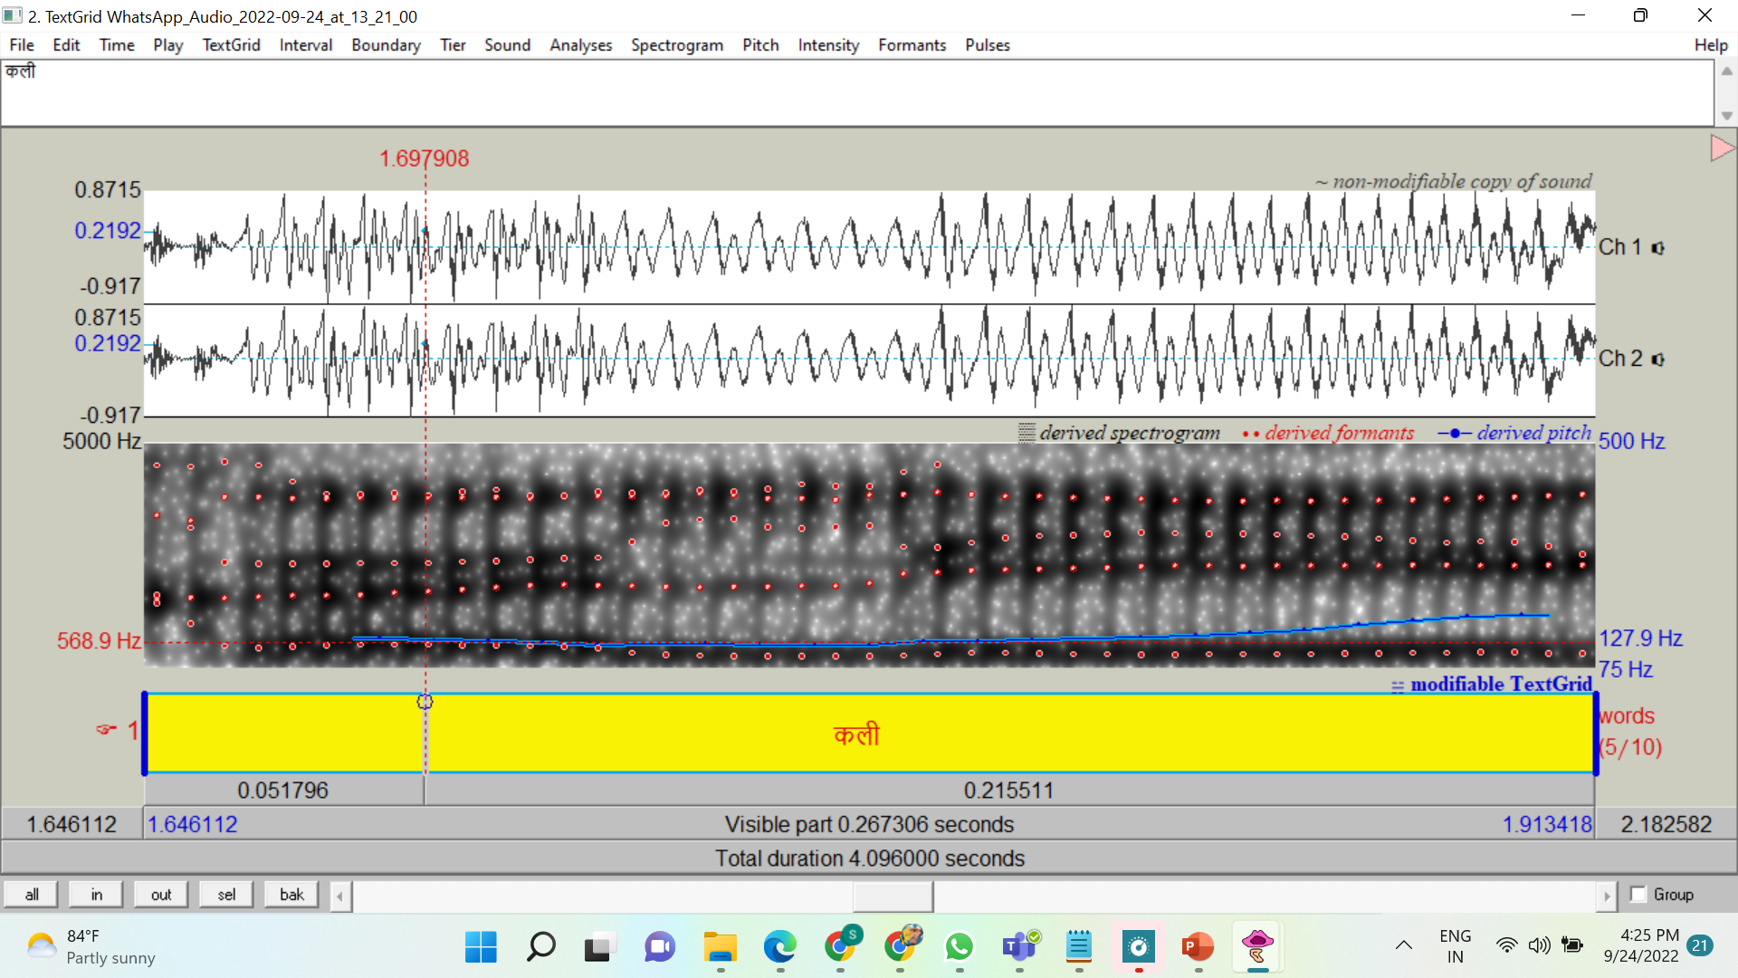

Fig.5

F1: 568.9 hz

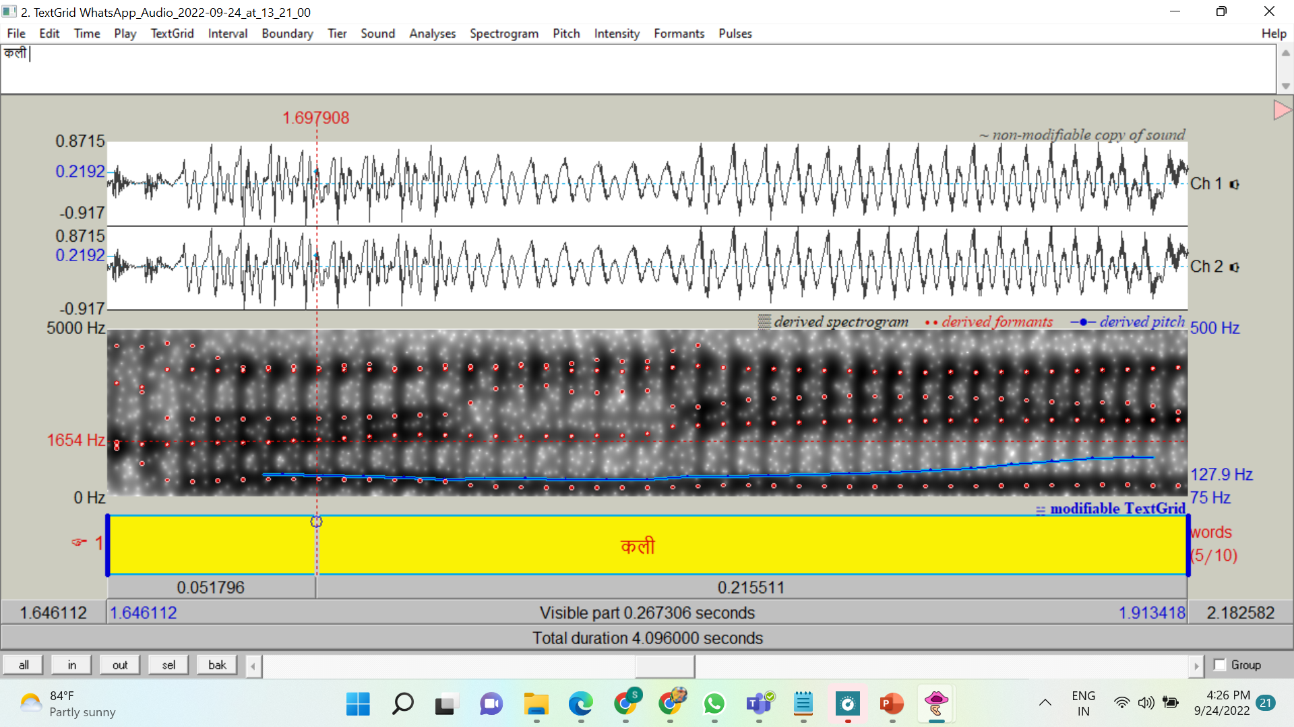

Fig.6

F2: 1654 hz

Similarly, we can analyze other sentences.

**बात बीत** गई

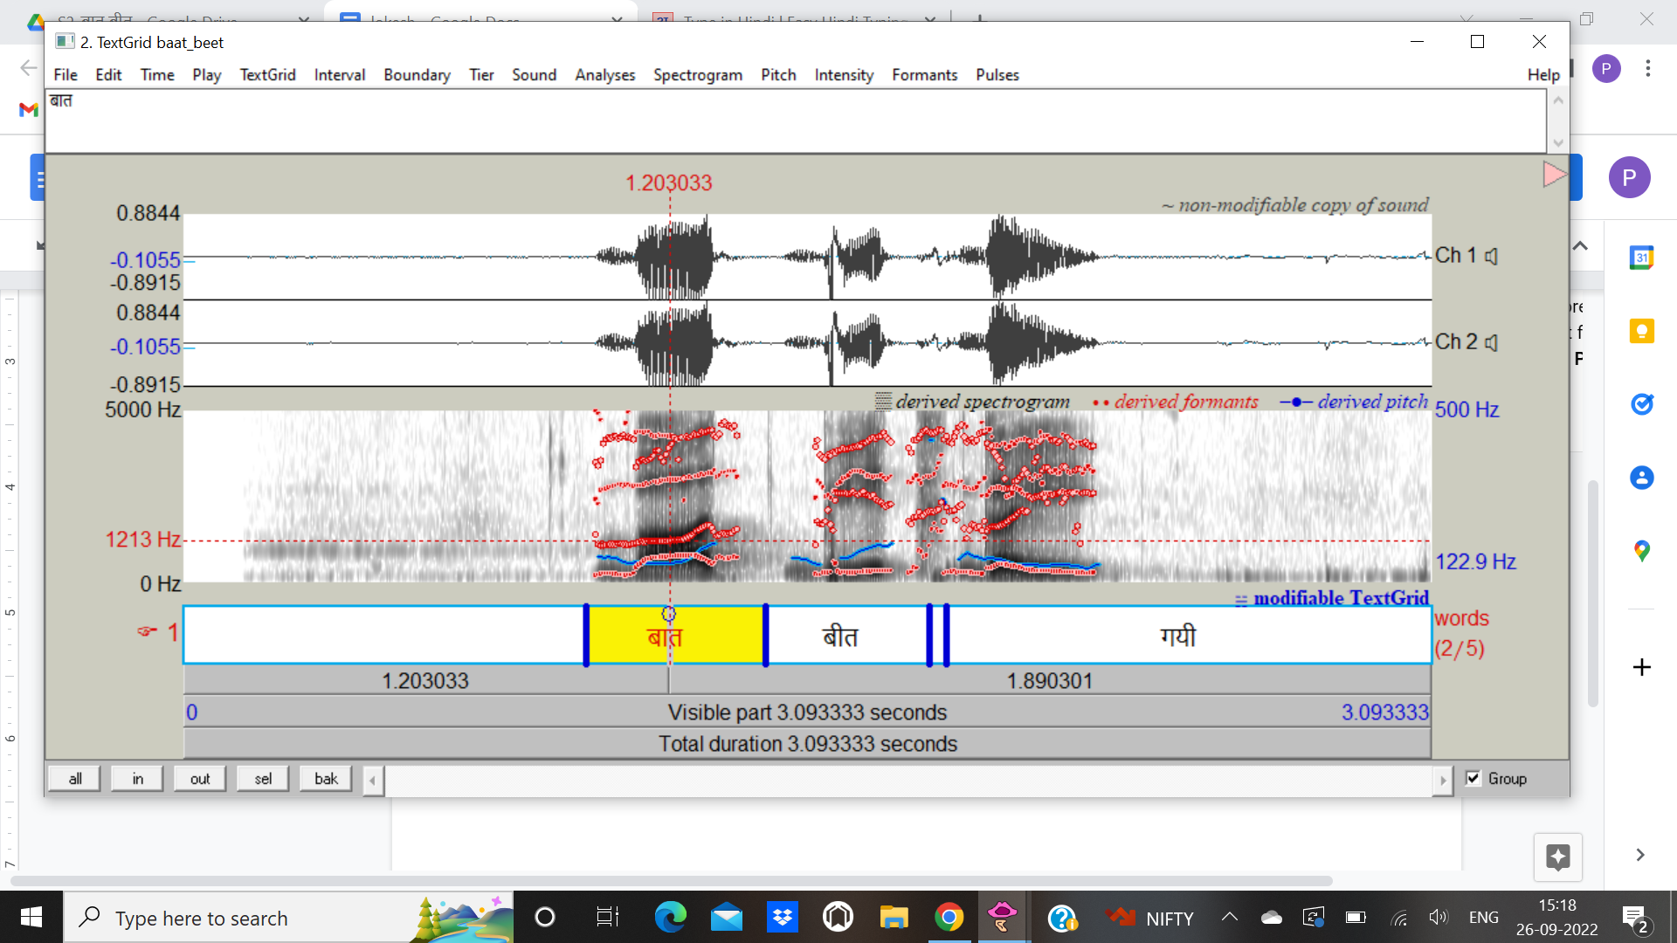

Fig.7

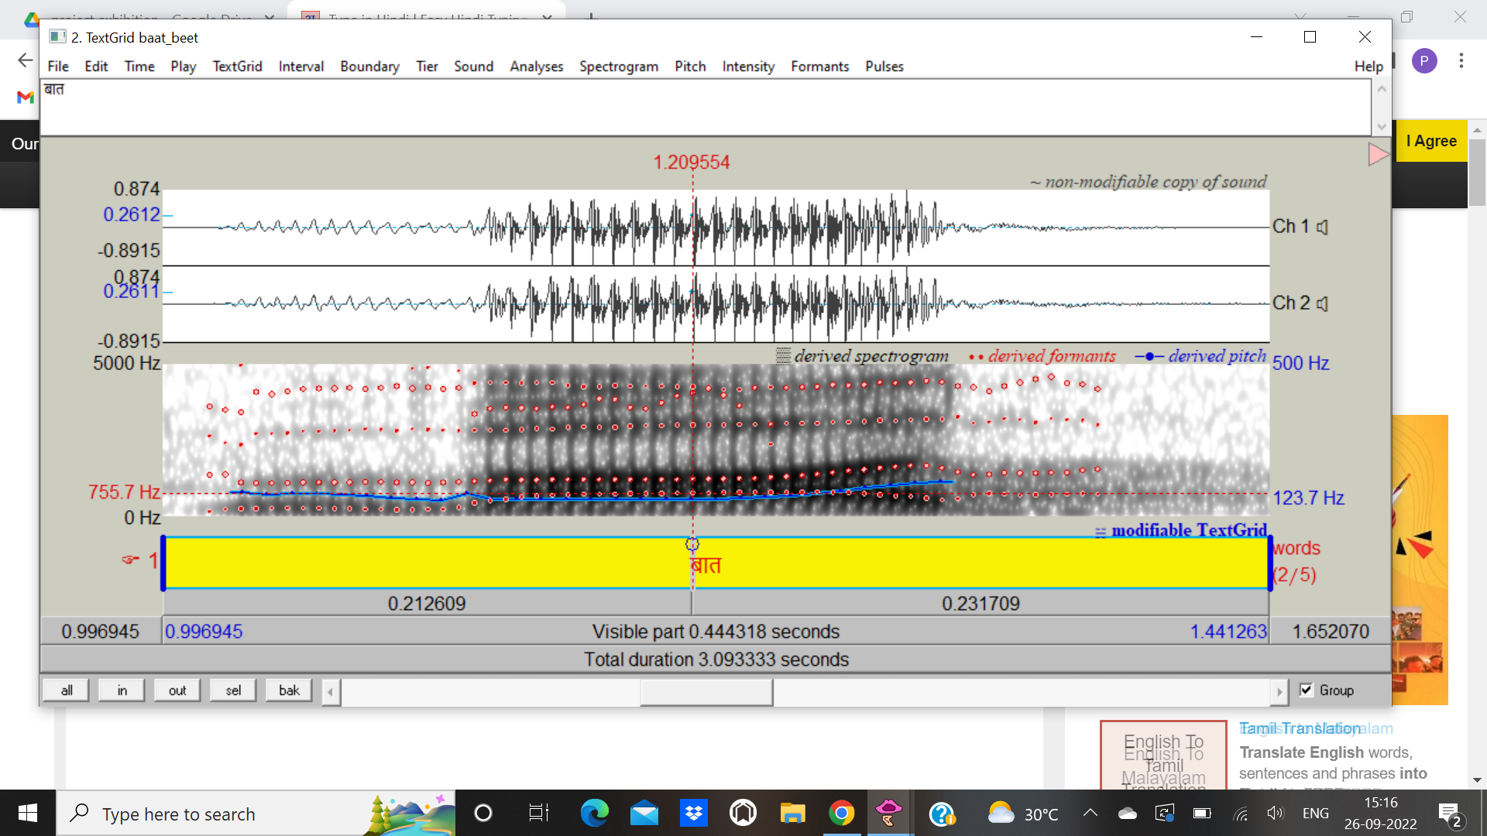

Fig.8

F1: 755.7 Hz

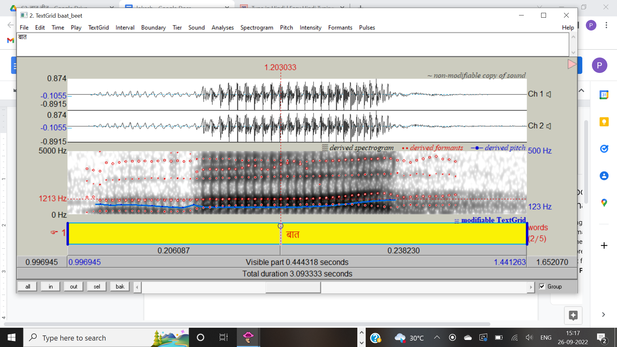

Fig.9

F2: 1213 Hz

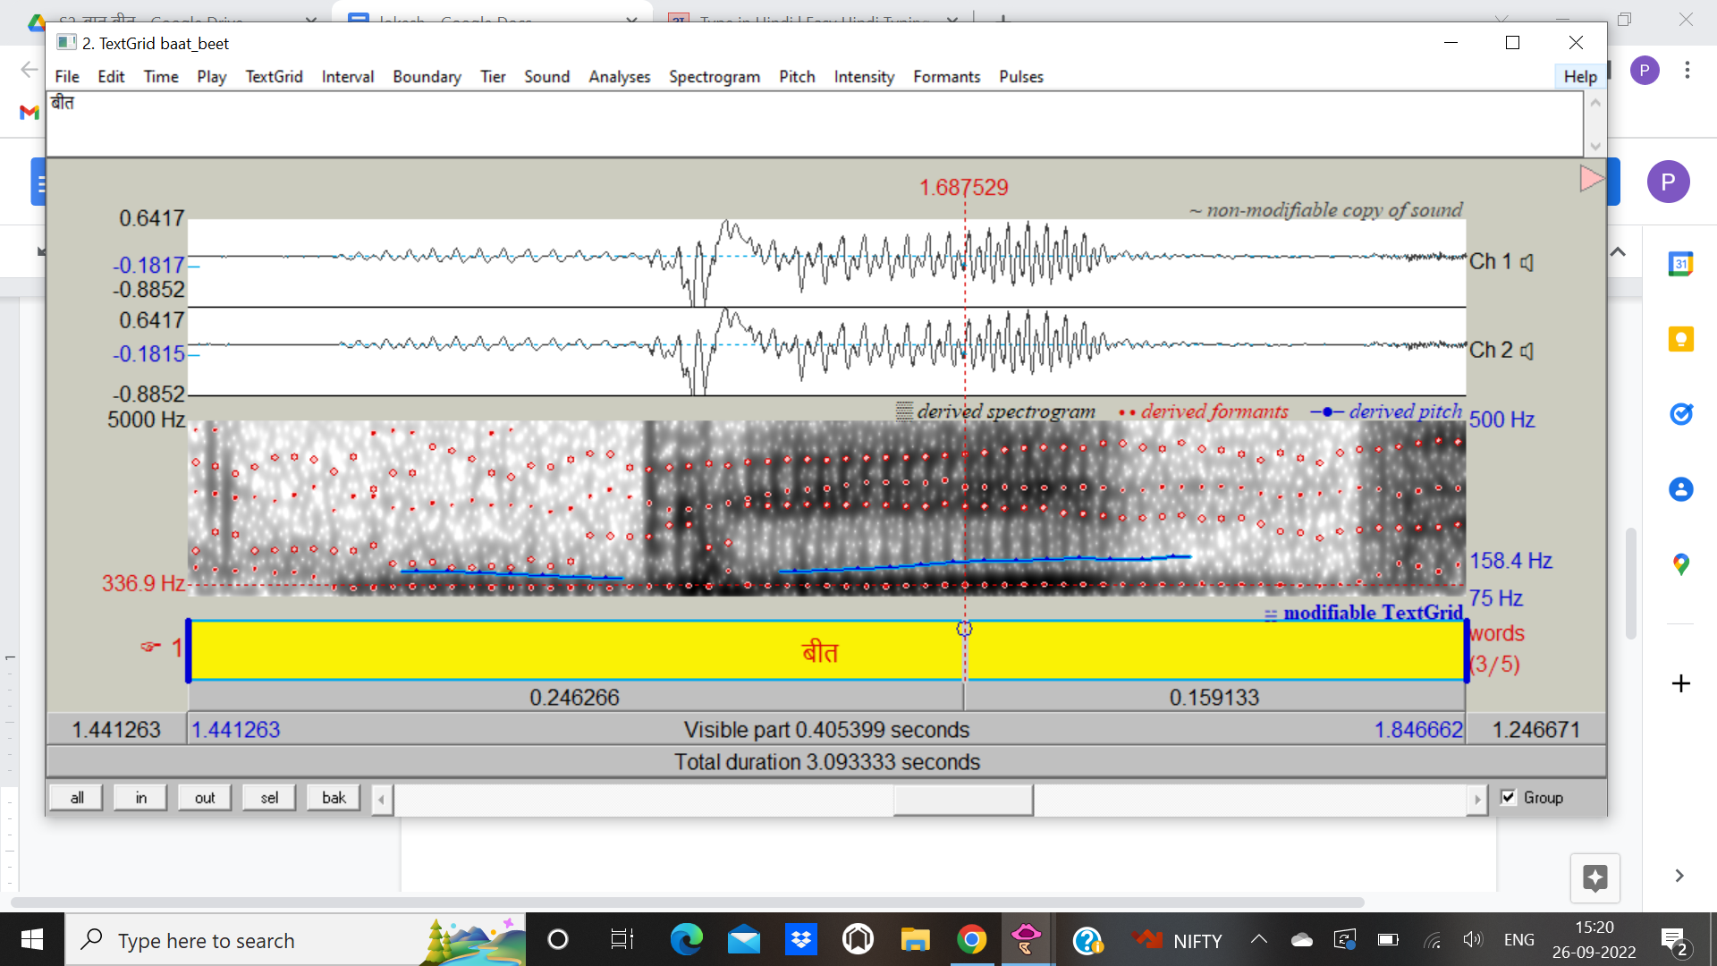

Fig.10

F1: 336.9 Hz

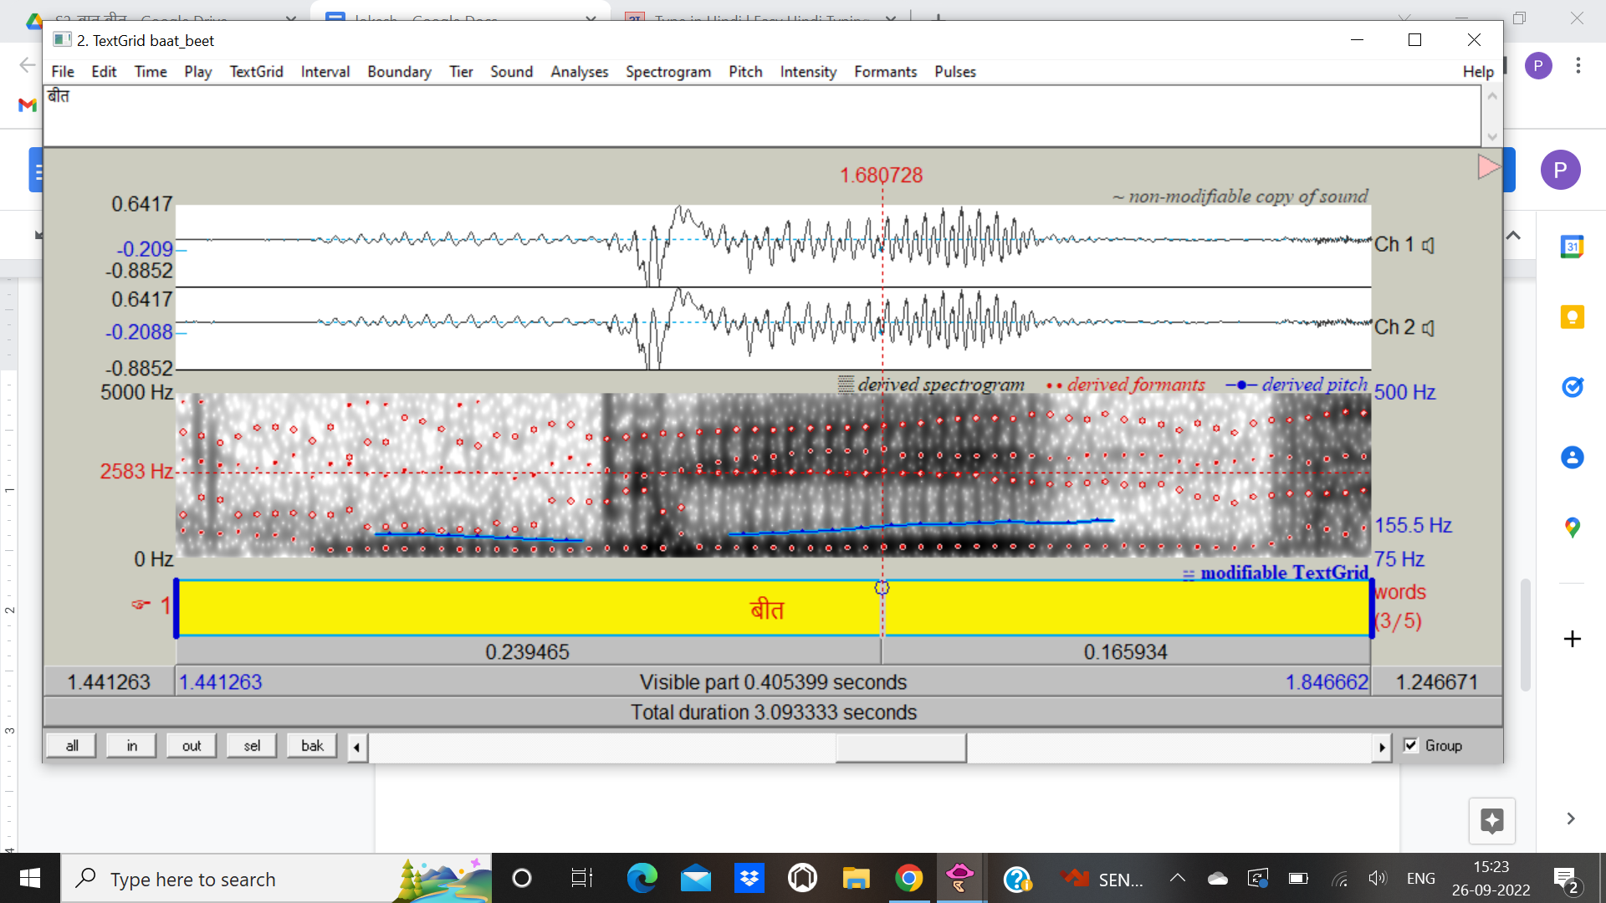

Fig.11

F2: 2583 Hz

**काश** **केश** होते

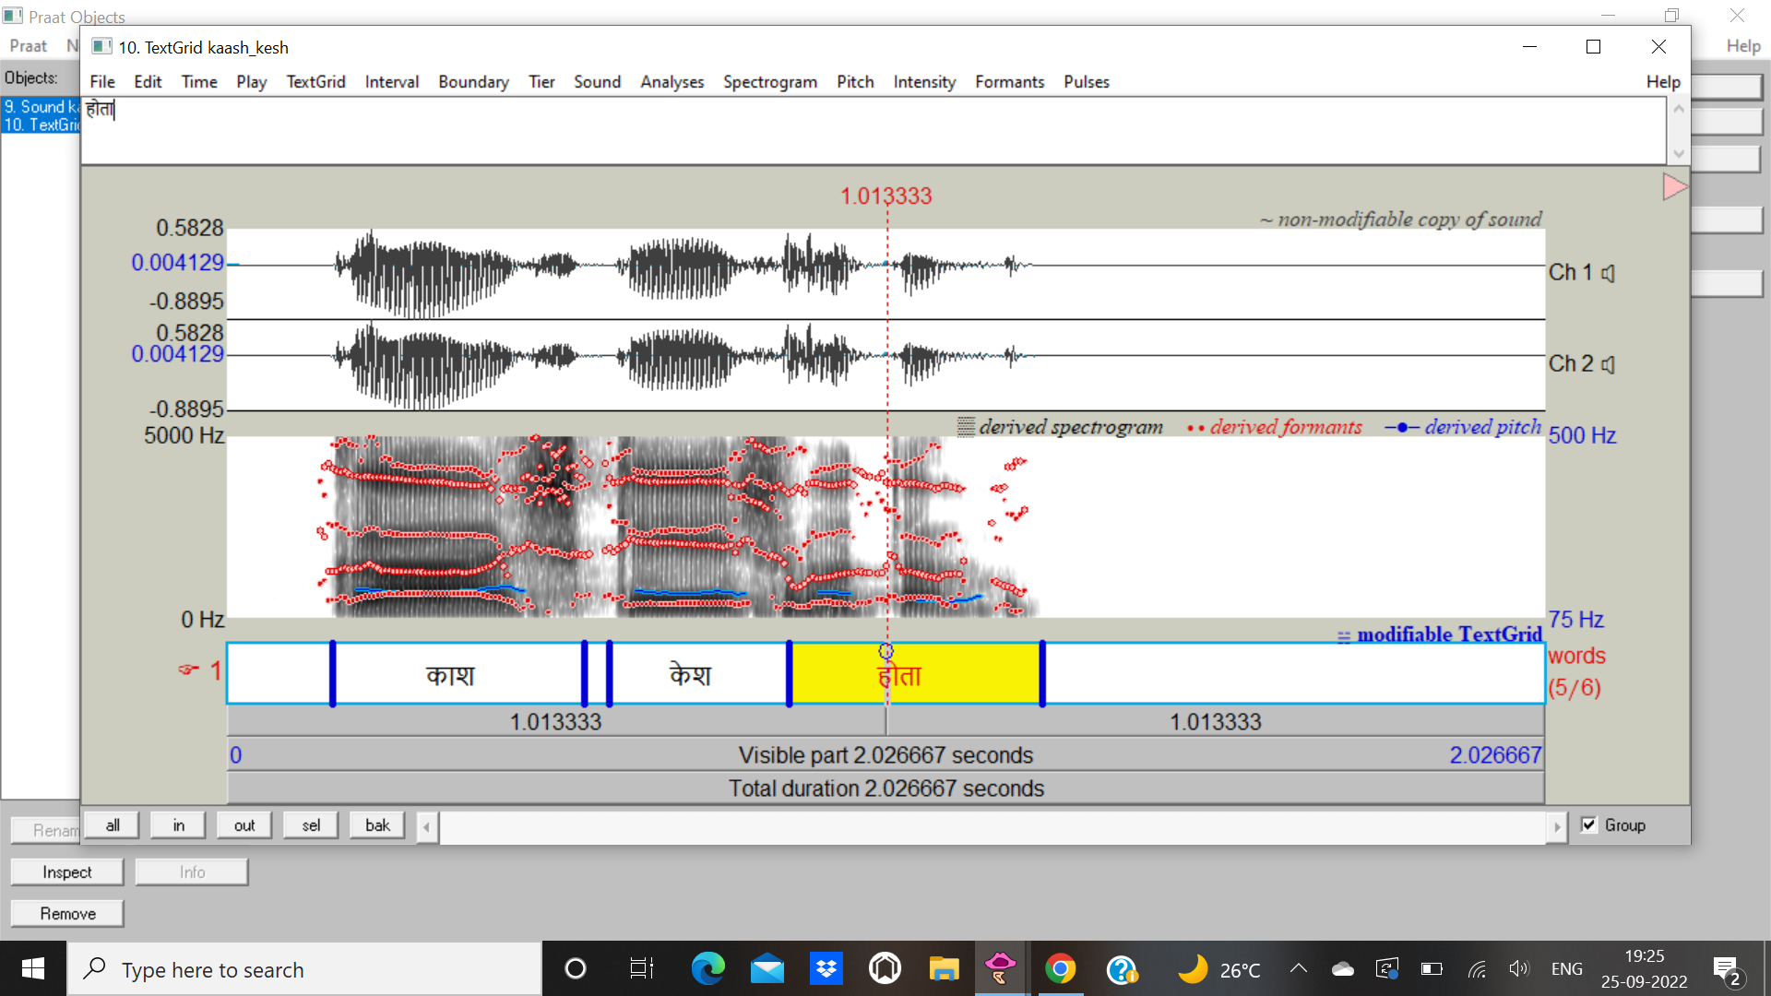

Fig.12

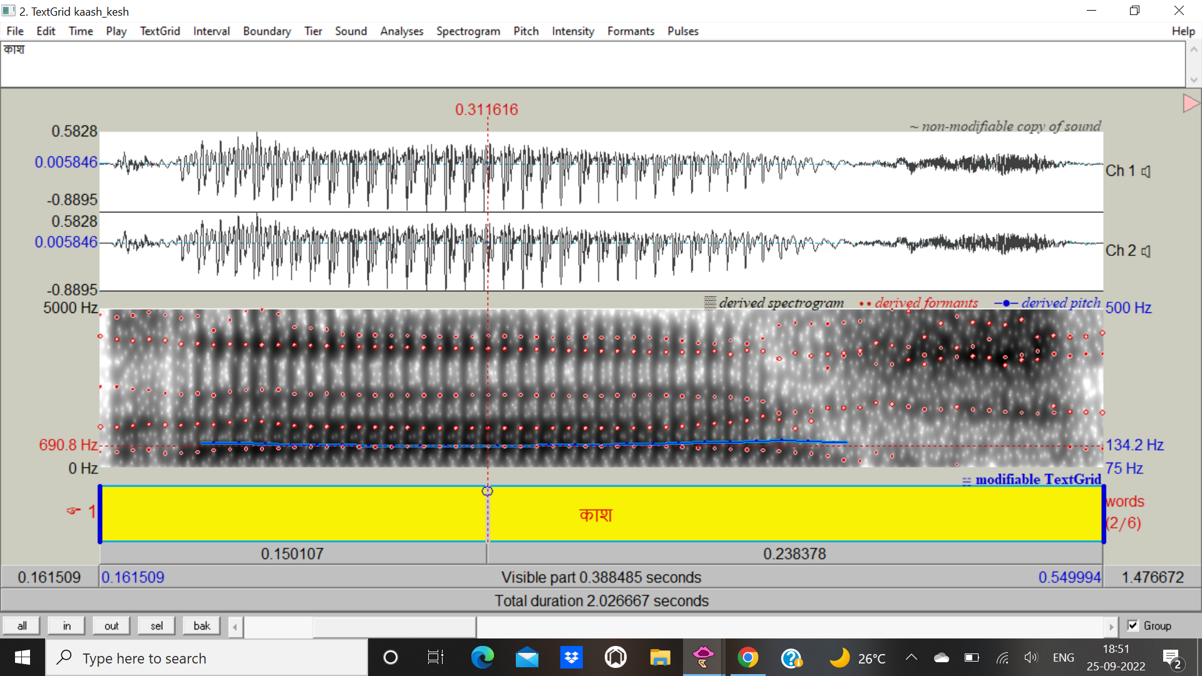

Fig.13

F1: 690.8 Hz

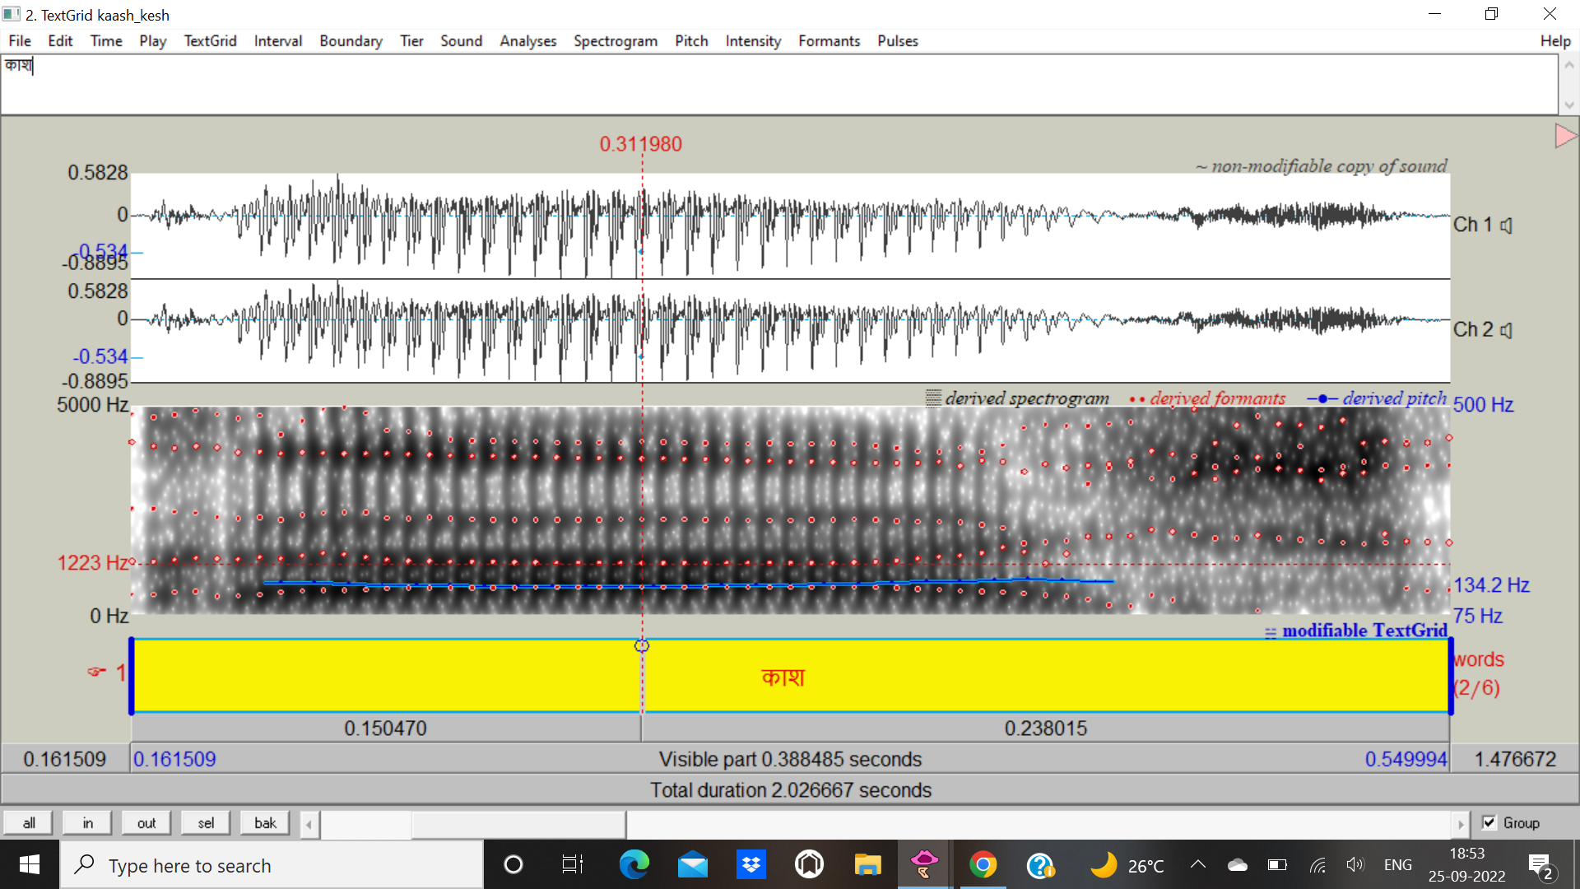

Fig.14

F2: 1223 Hz

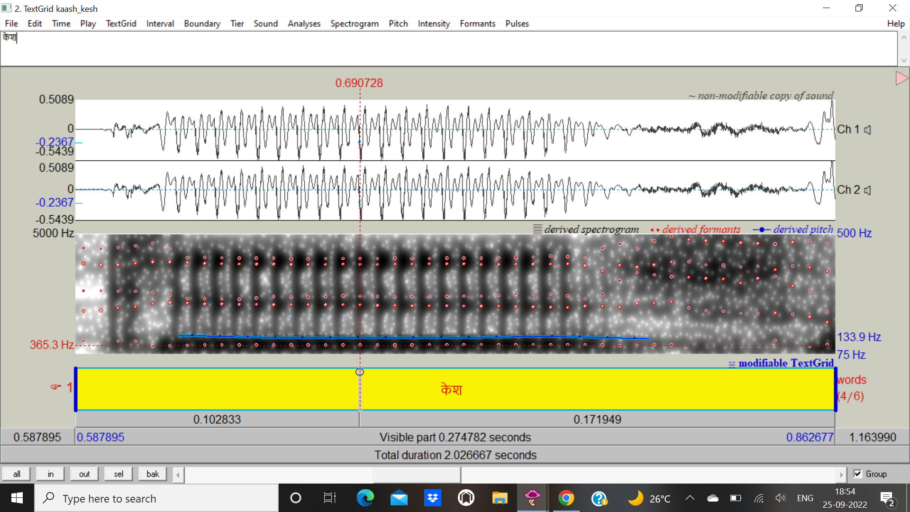

Fig.15

F1: 365.3 Hz

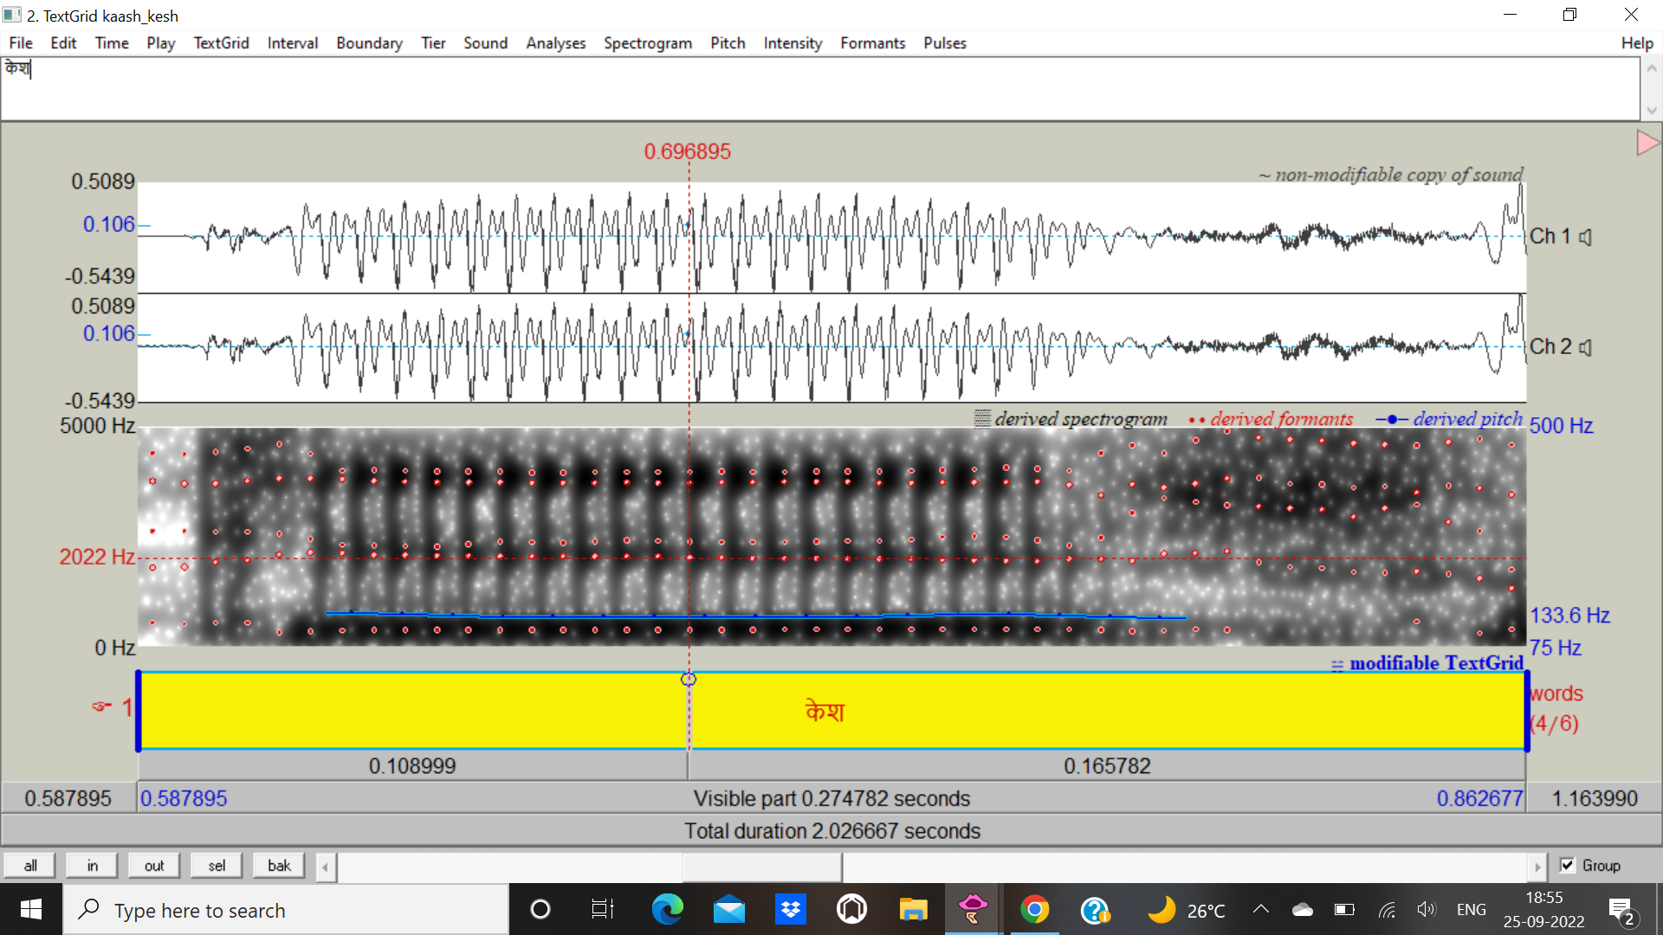

Fig.16

F2: 2022 Hz

**तेल तोल** लेना

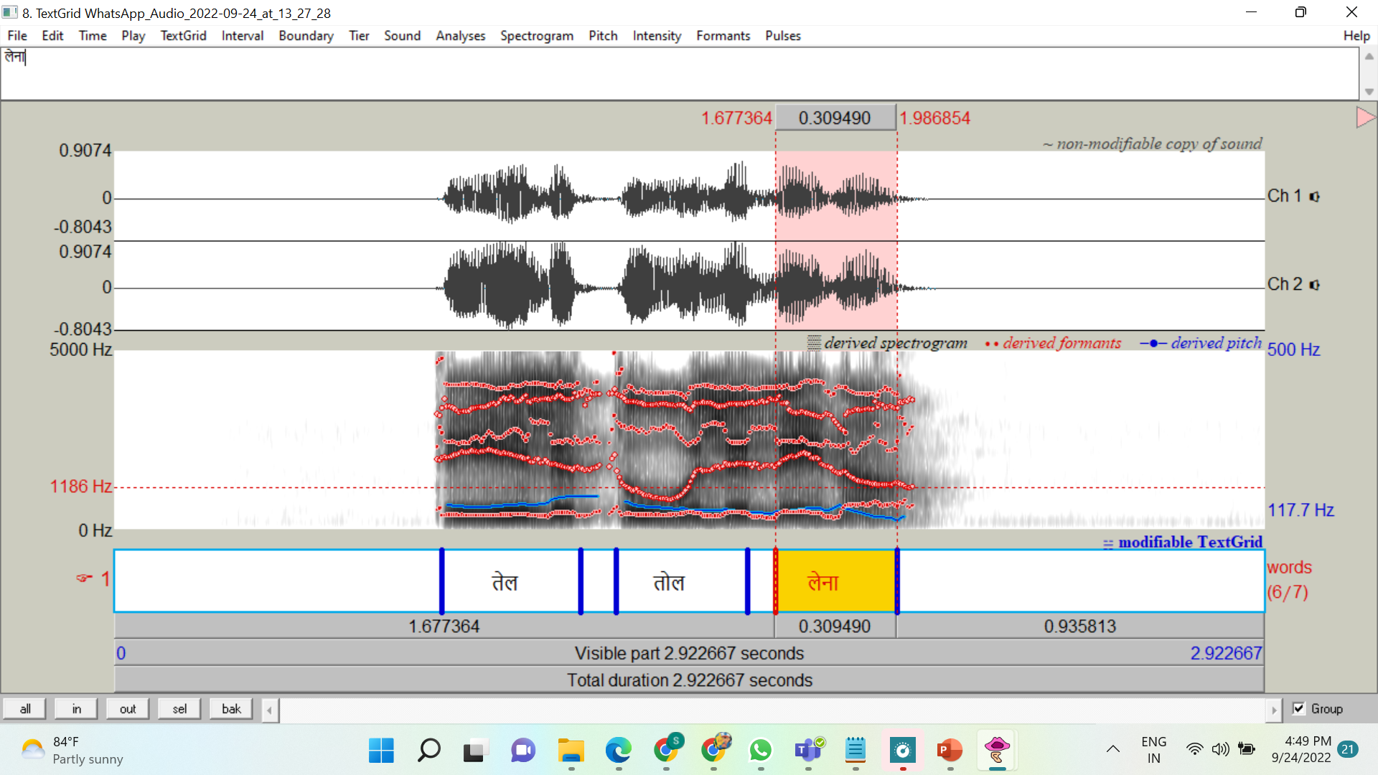

Fig.17

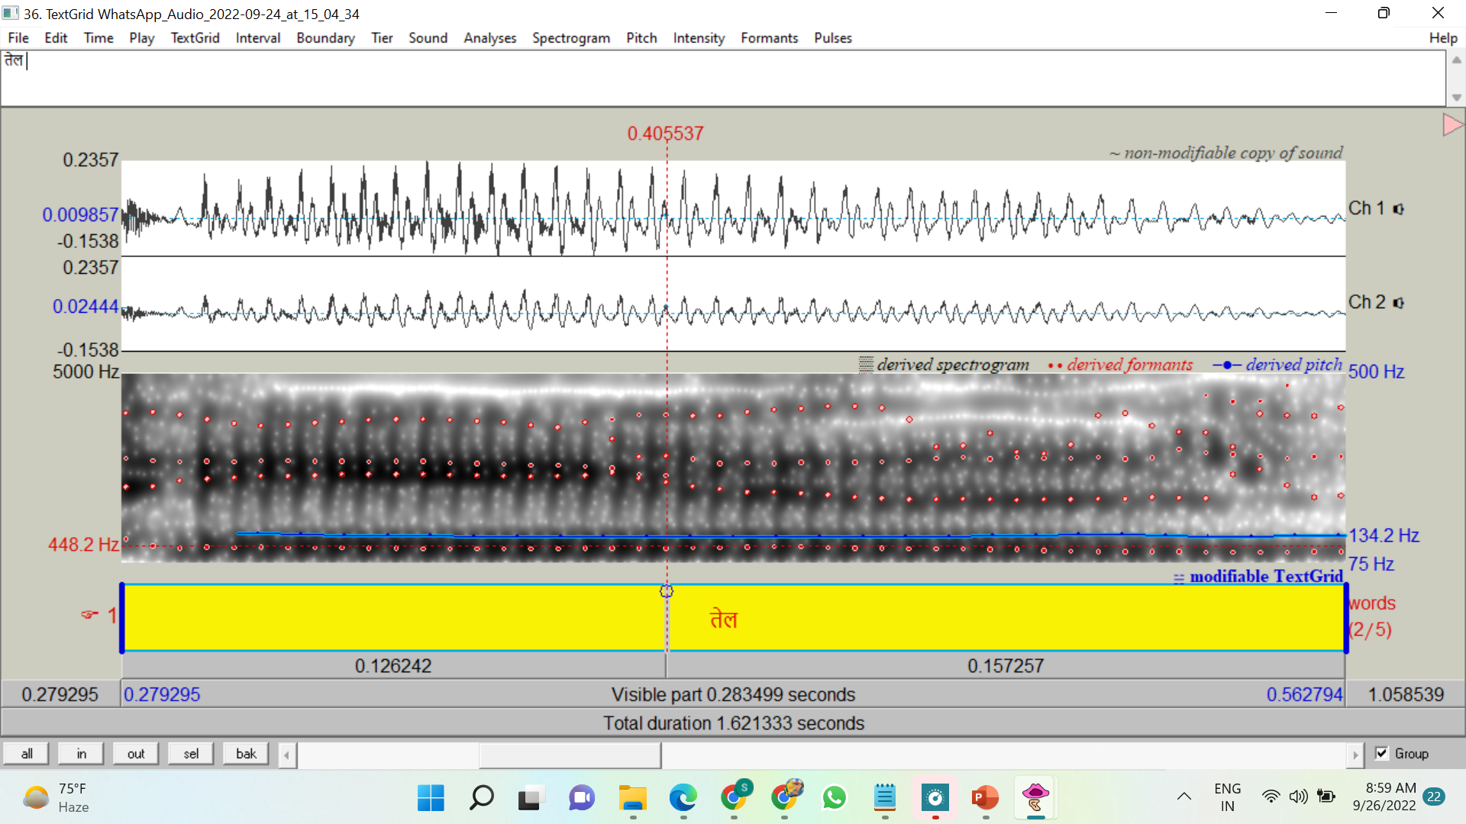

Fig.18

F1:448.2 Hz

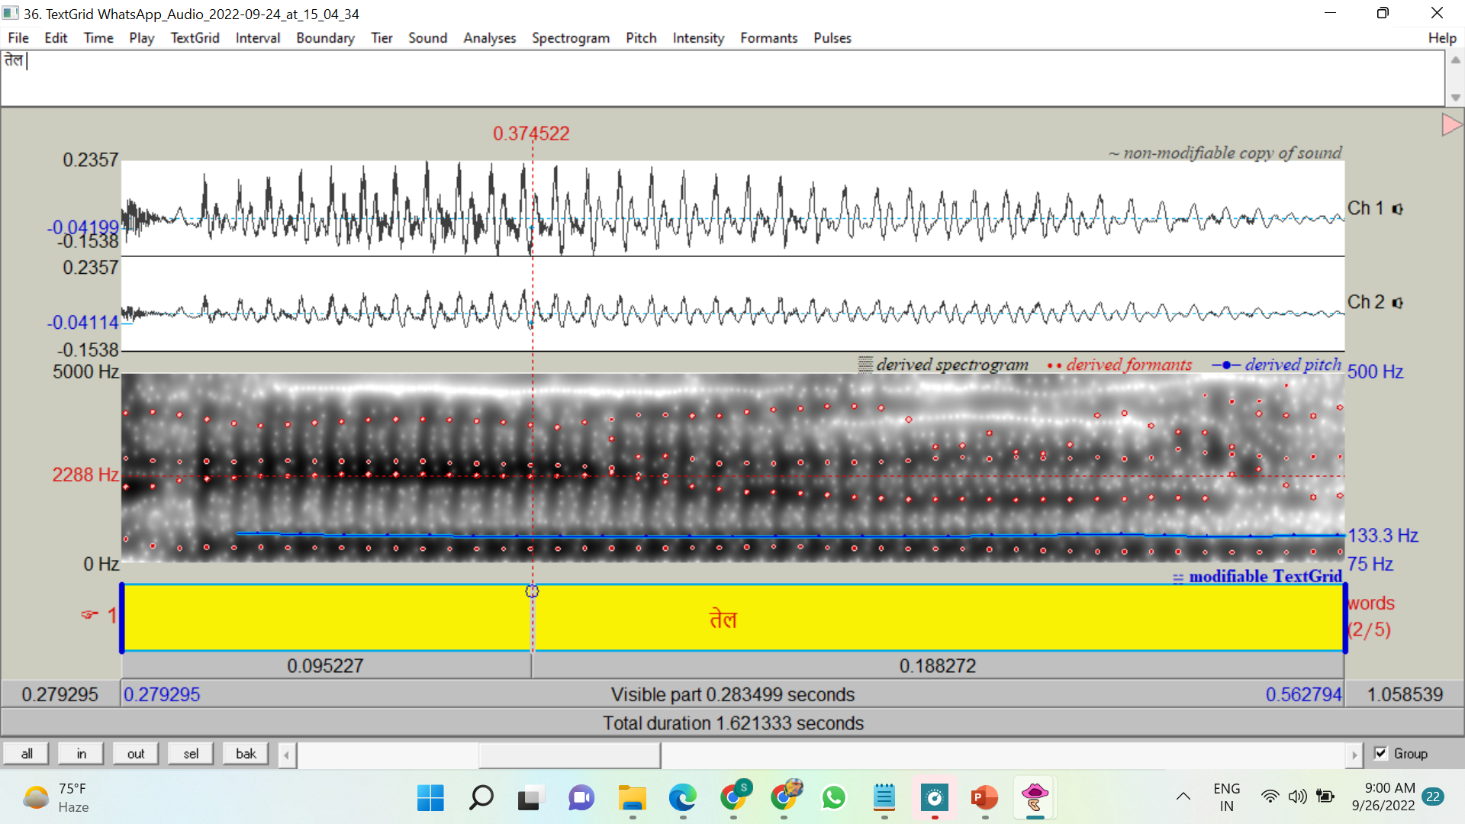

Fig.19

F2:2288 Hz

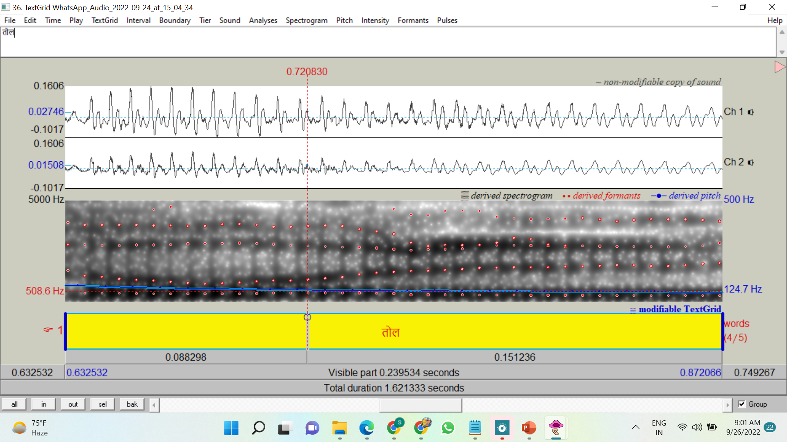

Fig.20

F1:508.6 Hz

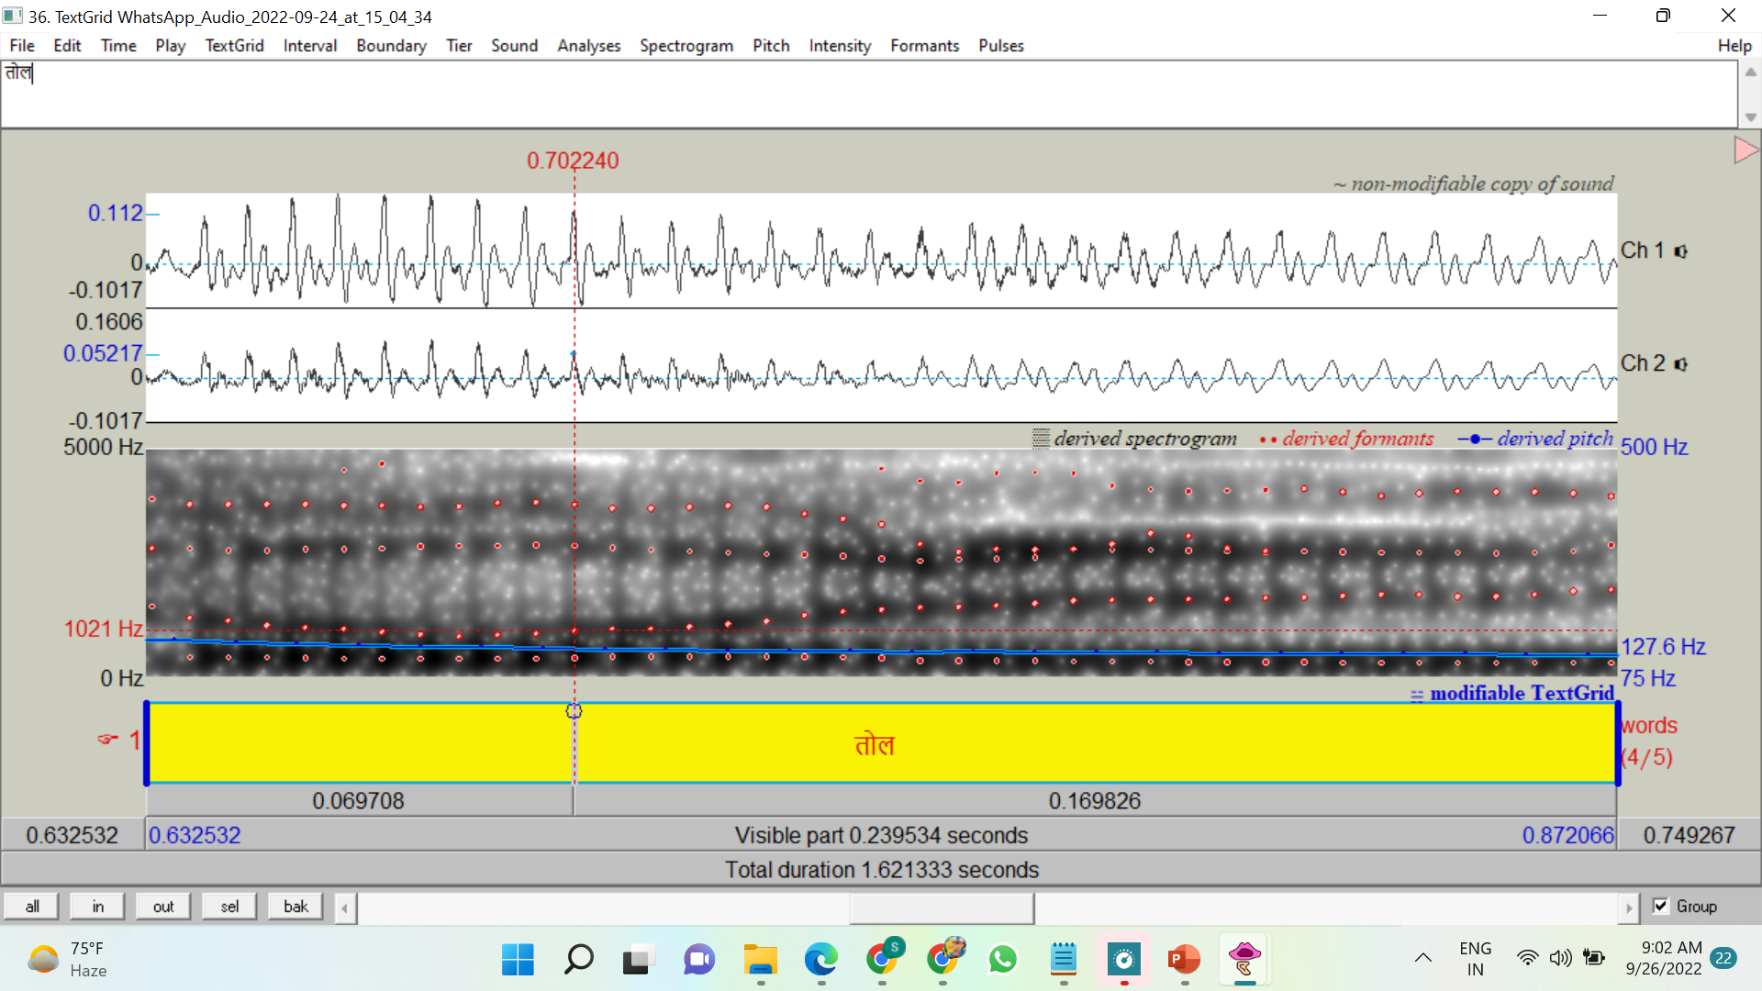

Fig.21

F2:1021 Hz

**तिल ताल** के पास है

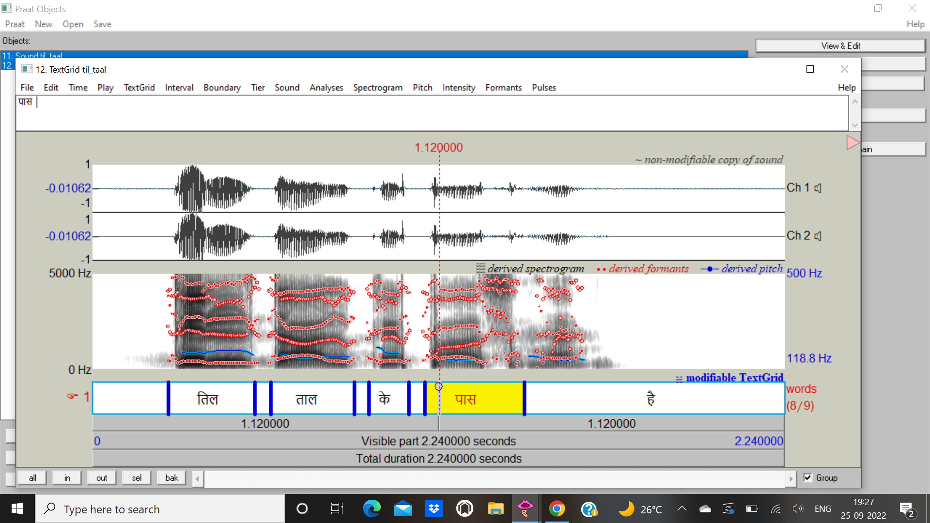

Fig.22

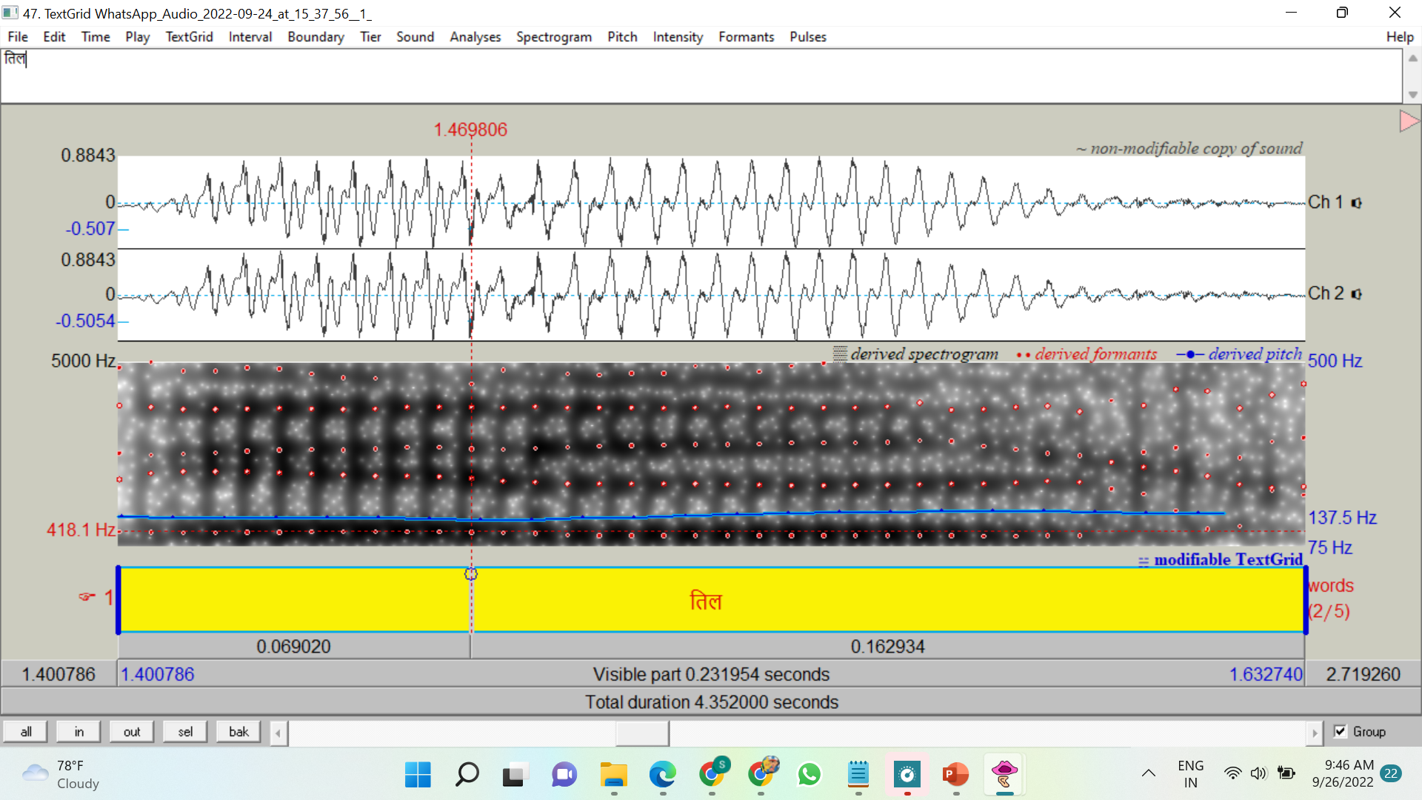

Fig.23

F1:418.1Hz

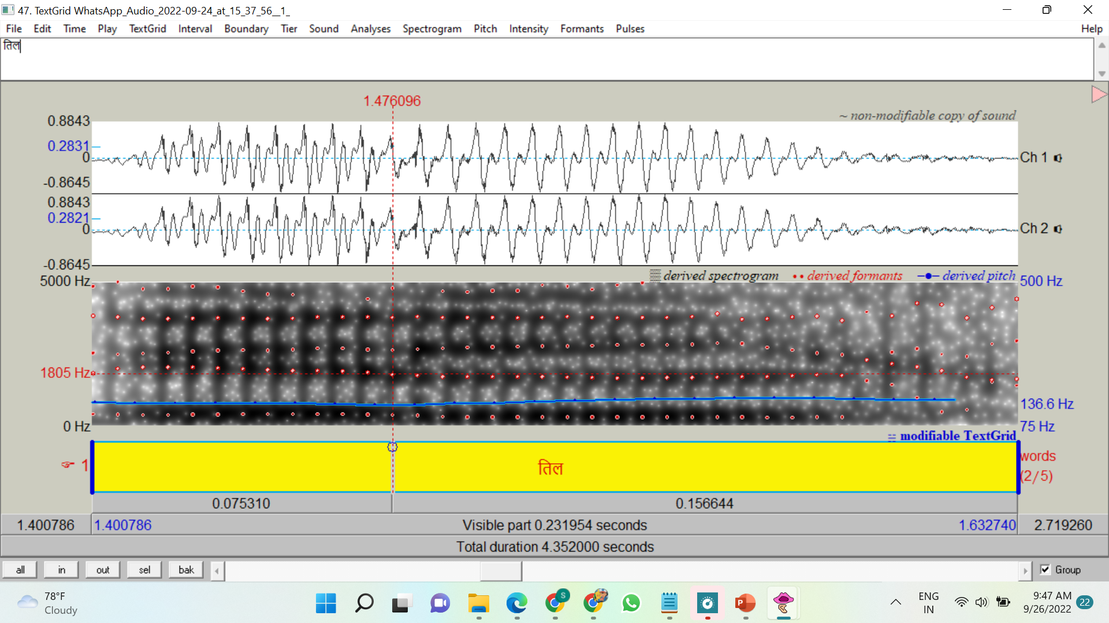

Fig.24

F2:1805 Hz

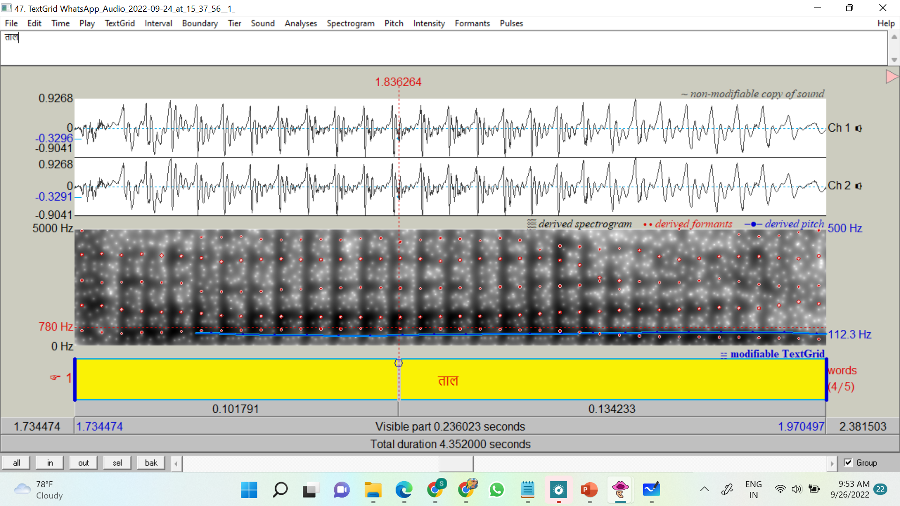

Fig.25

F1:780 Hz

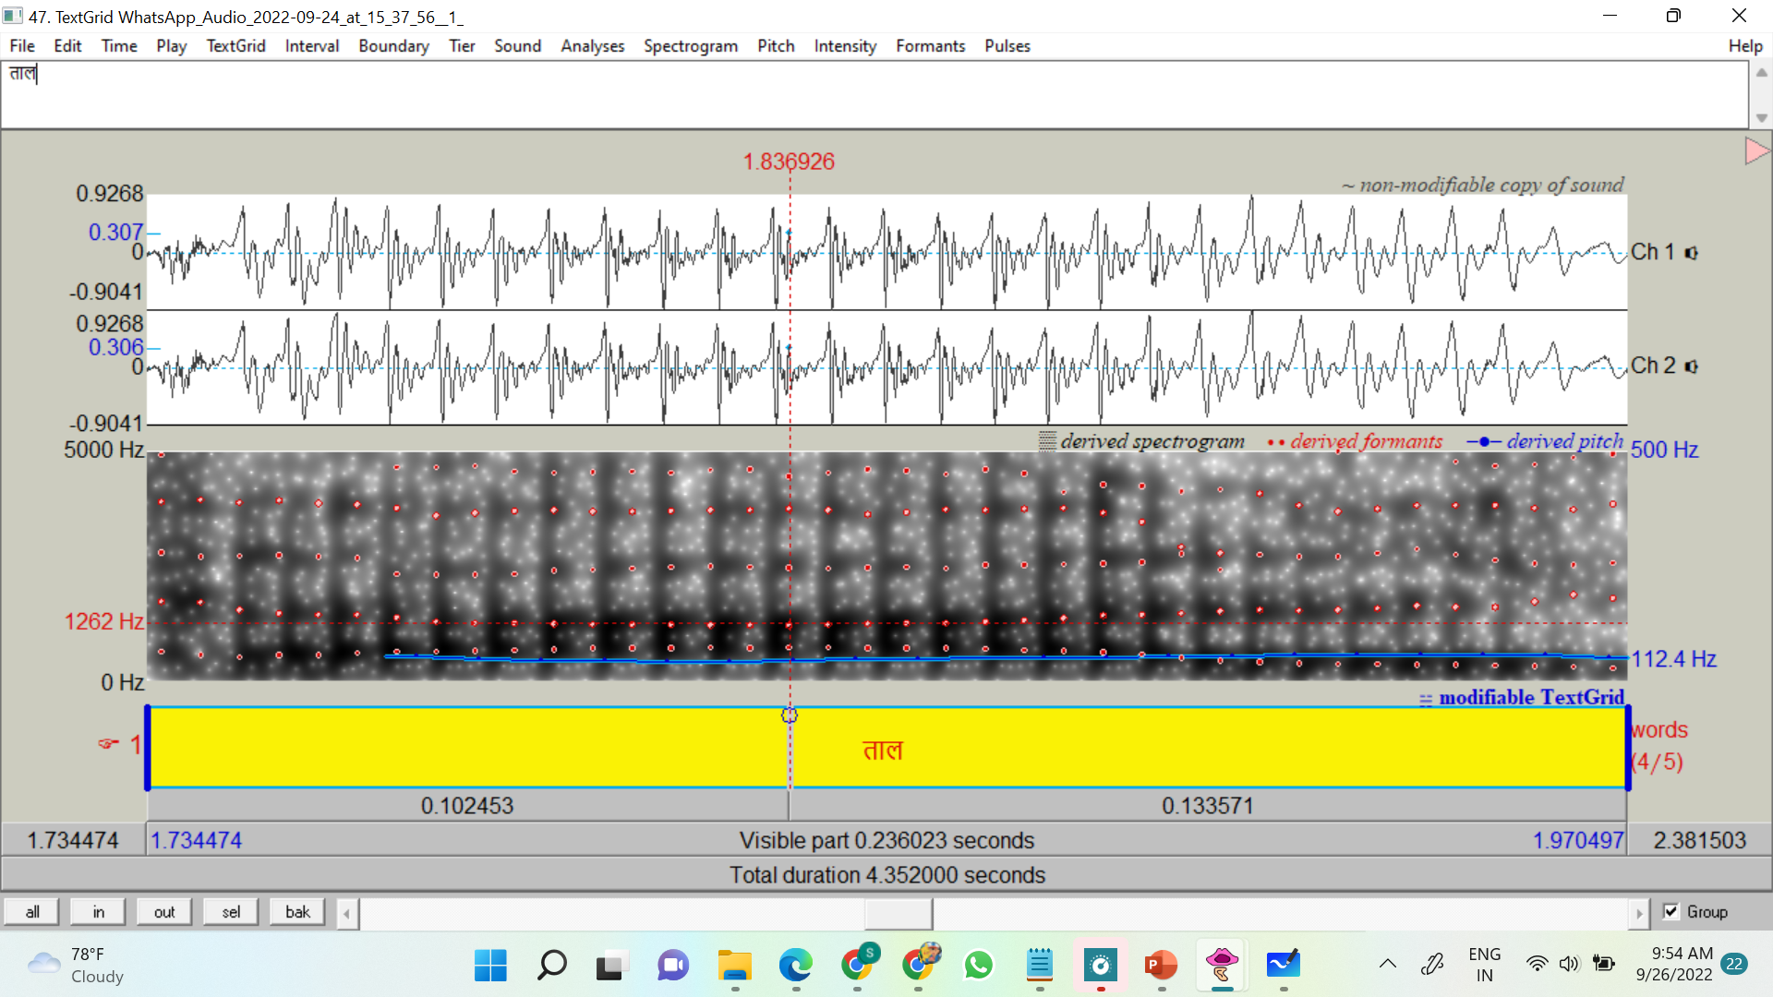

Fig.26

F2:1262 Hz

Similarly we perform the formant analysis on all the samples and retrieve the data that is further compiled into an excel file. We have ignored the data of ई because it is a hindi phoneme of इ.

**Results and Discussion**

For all mathematical calculations, the MS Excel function of AVERAGE for arithmetic mean calculation and STDEV.S for standard deviation is applied. If there are more than one data set for a particular vowel, arithmetic mean is considered of all the observed values and further function upon.

It was further noted that F1 and F2 formant standard deviation should not be more than 100 units.

The standard F1 and F2 values used for the comparison are derived from Catford, J.C. (1988) *A Practical Introduction to Phonetics*, Oxford University Press, p. 161. [ISBN](https://en.wikipedia.org/wiki/ISBN_(identifier)) [978-0198242178](https://en.wikipedia.org/wiki/Special:BookSources/978-0198242178) these are as follows:

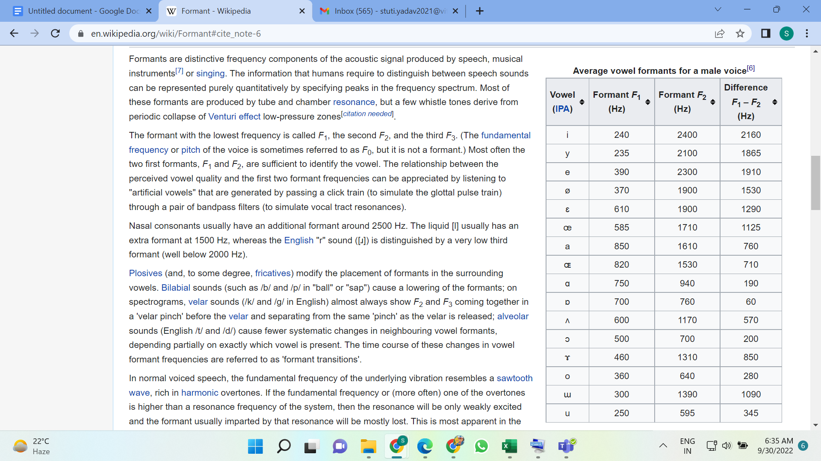

Fig.27

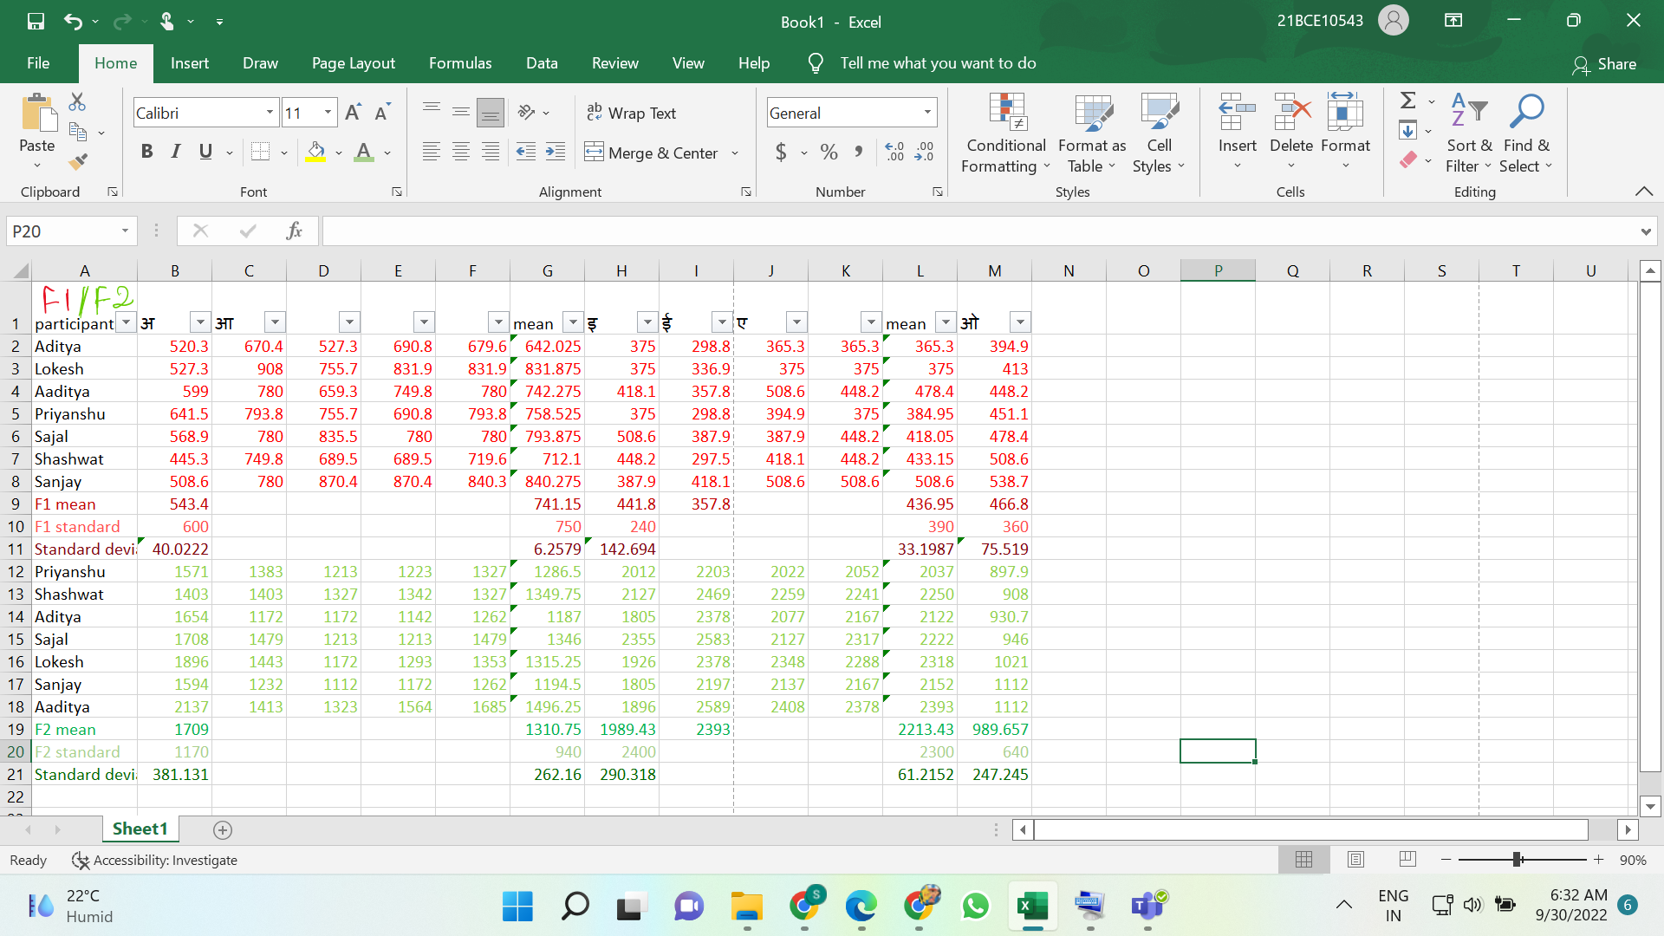

Table.1

As we have observed that F1 standard deviation is less than 100 thus no significant changes are observed hence no need for rectification and we can say that we have verified the existing frequencies using T-test.

A t-test is an inferential statistic used to determine if there is a significant difference between the means of two groups and how they are related.

Similarly analyzing all the data points we can see that drastic changes are observed in F1 standard deviation of इ, F2 standard deviation of अ (ʌ), आ(a:), इ(I), ओ (o). All are greater than 100 units.

**Conclusion**

Hence we can conclude that the current NLP system is no longer accurate according to the current diverse scenario and thus needs to be updated to the latest values for more efficient and accurate results.

We have also verified that the F1 values of अ (ʌ), आ(a:), ए(e), ओ (o) and F2 values of ए(e) are still valid and hence not needed to be rectified.

**References**

1.<https://en.wikipedia.org/wiki/Formant#cite_ref-6>

2.Catford, J.C. (1988) *A Practical Introduction to Phonetics*, Oxford University Press, p. 161. [ISBN](https://en.wikipedia.org/wiki/ISBN_(identifier)) [978-0198242178](https://en.wikipedia.org/wiki/Special:BookSources/978-0198242178)

3. A course in phonetics by Ladefoged (2006)

4.<https://corpus.eduhk.hk/english_pronunciation/index.php/1-2-introduction-of-praat/#:~:text=Praat%20is%20a%20freeware%20program,uva.nl%2FPraat%2F>.

5.https://ieeexplore.ieee.org/document/8524273/keywords#keywords